Лабораторна робота №2
Написання unit-тестів з використанням мови Python
Лісинг 2.1 test_case.py
import unittest
from eshop import Product, ShoppingCart, Order
from unittest.mock import MagicMock
class TestEshopExtended(unittest.TestCase):
def setUp(self):
self.product = Product(name='Test', price=100.0, available_amount=10)
self.cart = ShoppingCart()
def test_mock_add_product(self):
self.product.is_available = MagicMock(return_value=True)
self.cart.add_product(self.product, 5)
self.product.is_available.assert_called_with(5)
def test_add_available_amount(self):
self.cart.add_product(self.product, 5)
self.assertIn(self.product, self.cart.products)
def test_add_non_available_amount(self):
with self.assertRaises(ValueError):
self.cart.add_product(self.product, 15)
def test_product_initialization(self):
self.assertEqual(self.product.name, 'Test')
self.assertEqual(self.product.price, 100.0)
def test_calculate_total_single_item(self):
self.cart.add_product(self.product, 3)
self.assertEqual(self.cart.calculate_total(), 300.0)
def test_calculate_total_multiple_items(self):
p2 = Product('Apple', 10.0, 50)
self.cart.add_product(self.product, 1)
self.cart.add_product(p2, 5)
self.assertEqual(self.cart.calculate_total(), 150.0)
def test_remove_product_logic(self):
self.cart.add_product(self.product, 1)
self.cart.remove_product(self.product)
self.assertNotIn(self.product, self.cart.products)
def test_add_zero_amount(self):
self.cart.add_product(self.product, 0)
self.assertEqual(self.cart.products[self.product], 0)
def test_add_negative_amount(self):
with self.assertRaises(ValueError):
self.cart.add_product(self.product, -1)
def test_order_reduces_stock(self):
self.cart.add_product(self.product, 2)
order = Order(self.cart)
order.place_order()
self.assertEqual(self.product.available_amount, 8)
def test_cart_clears_after_order(self):
self.cart.add_product(self.product, 1)
Order(self.cart).place_order()
self.assertEqual(len(self.cart.products), 0)
def test_is_available_exact_amount(self):
self.assertTrue(self.product.is_available(10))
def test_is_available_exceed_amount(self):
self.assertFalse(self.product.is_available(11))
if __name__ == '__main__':
unittest.main()

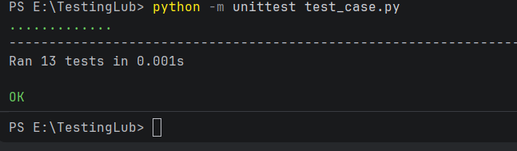
Рисунок 1 – результат виконання тестів
Висновок: ми навчились писати unit-тести з використанням мови Python

